**ABSTRACT—Tropical cyclones are very common in many part of the world and the destruction caused by them are very severe and hence it is essential to predict the tropical cyclones in advance with very high accuracy rate.**

**Tropical cyclone intensity is an important parameter that determines the level of preparation and response required to minimize the cyclone damage. Traditional methods of estimating tropical cyclone intensity are often manual, relying on visual interpretation of satellite imagery which were found to be more subjective, so we used Deep Learning based Convolutional Neural Network (CNN) model to predict the intensity of tropical cyclones. In this paper, we present a data-driven approach that uses CNN models to automate tropical cyclone intensity estimates from satellite images and to show different parameters like intensity, wind speed estimations, etc. of tropical cyclone on a web page.**

**We demonstrate the effectiveness of our method by testing tropical cyclone imagery on a large dataset using our propose CNN model and comparing it with existing methods for estimating intensity. Our results demonstrate the performance of our CNN models than existing methods in terms of accuracy and speed, and can enhance reliable and timely estimates of hurricane intensity accuracy. The proposed method has the potential to include tropical cyclone existing monitoring and forecasting system.**

**Index Terms—Deep learning, wind speed estimation, data-driven approach.**

1.INTRODUCTION  
  
A tropical cyclone is a rapidly rotating storm system characterised by a low-pressure centre, a closed low-level atmospheric circulation, strong winds, and a spiral arrangement of thunderstorms that produces heavy rain and squalls. Depending on the location and strength, a tropical cyclone is called by different names, including hurricane, typhoon, tropical depression, tropical storm, cyclonic storm, or simply cyclone.

A hurricane is a strong tropical cyclone that occurs in the Atlantic Ocean or north eastern Pacific Ocean, and a typhoon occurs in the north western Pacific Ocean. In the Indian Ocean, South Pacific, or (rarely) South Atlantic, comparable storms are referred to as "tropical cyclones", and such storms in the Indian Ocean can also be called "severe cyclonic storms".

"Tropical" refers to the geographical origin of these systems, which form almost exclusively over tropical seas. "Cyclone" refers to their winds moving in a circle, whirling round their central clear eye, with their surface winds blowing counter clockwise in the Northern Hemisphere and clockwise in the Southern Hemisphere. The opposite direction of circulation is due to the Coriolis effect. Tropical cyclones typically form over large bodies of relatively warm water. They derive their energy through the evaporation of water from the ocean surface, which ultimately condenses into clouds and rain when moist air rises and cools to saturation. This energy source differs from that of mid-latitude cyclonic storms, such as nor'easters and European windstorms, which are powered primarily by horizontal temperature contrasts. Tropical cyclones are typically between 100 and 2,000 km (62 and 1,243 mi) in diameter. Every year tropical cyclones affect various regions of the globe including the Gulf Coast of North America, Australia, India, and Bangladesh.

1.1 How do they form?

In the tropics there is a broad zone of low pressure which stretches either side of the equator. The winds on the north side of this zone blow from the north-east (the north-east trades) and on the southern side blow from the south-east (south-east trades).

Within this area of low pressure the air is heated over the warm tropical ocean. This air rises in discrete parcels, causing thundery showers to form. These showers usually come and go, but from time to time, they group together into large clusters of thunderstorms. This creates a flow of very warm, moist, rapidly rising air, leading to the development of a centre of low pressure, or depression, at the surface.

There are various trigger mechanisms required to transform these cloud clusters into a tropical cyclone. These trigger mechanisms depend on several conditions being 'right' at the same time. The most influential factors are:

1. A source of warm, moist air derived from tropical oceans with sea surface temperatures normally in the region of, or in excess, of 27 °C

2. Winds near the ocean surface blowing from different directions converging and causing air to rise and storm clouds to form winds which do not vary greatly with height - known as low wind shear.

This allows the storm clouds to rise vertically to high levels, sufficient distance from the equator to provide spin or twist.

The Coriolis force caused by the rotation of the Earth helps the spin of this column of rising air. The development of the surface depression causes an increase in the strength of the trade winds. The spiralling winds accelerate inwards and upwards, releasing heat and moisture as they do so

2.Related Work

2.1 Dvorak Method

The Dvorak Technique is a widely used method for estimating the intensity of tropical cyclones based on satellite imagery. Dvorak technique are considered the gold standard for satellite image-based tropical cyclone intensity estimation among tropical meteorologists. The main concept of the Dvorak technique is that the shape and coverage of the cloud field determine the intensity of the cyclone. Features such as the length and curvature of the storm’s outer rainbands are analyzed to arrive at a particular T-number. But Dvorak Technique has some drawbacks of its own, because the Dvorak technique relies on human interpretation of features in a tropical cyclone cloud field, two well-trained analysts can assign different intensity estimates. Additionally, subtle differences in T-number can result in differences in maximum wind speed by 12 knots or more at hurricane intensities.

2.2 Advanced Dvorak Technique(ADT)

The Advanced Dvorak Technique (ADT) is an enhanced version of the original Dvorak Technique for estimating the intensity of tropical cyclones. ADT takes into account a wider range of storm features, including cloud top temperature, storm size, and asymmetry of the storm's structure. It also uses microwave satellite data to provide a more accurate estimate of the storm's center and overall intensity. While the ADT improves upon the manual Dvorak technique, model performance struggles on weaker storms that tend to have a more disorganized cloud distribution and empirical thresholds are retained to constrain the change in cyclone intensity with time.

2.3 Deviation-Angle Variance Technique (DAVT)

DAVT works by analyzing the deviation angles between the microwave emissions of the storm and a reference background. The technique compares the variance of these deviation angles over time to estimate the rate of change of the storm's intensity. This technique has two main limitations: (i) it requires images with properly marked tropical cyclone centers and (ii) it uses different models and fitting parameters for tropical cyclones in different regions

2.4 Convolutional neural networks(CNN)

Convolutional neural networks (CNNs) have been used for many different computer vision tasks ranging from image classification to object detection and even visual saliency detection. In this method, the CNN is trained on a large dataset of satellite images of tropical cyclones with known intensity values. The CNN learns to recognize patterns in the images that are indicative of higher wind speeds and more intense storms. Once the CNN is trained, it can be used to predict the intensity of new tropical cyclones based on satellite imagery.

One of the advantages of CNN-based intensity estimation is that it can provide accurate results even in cases where other methods may not be effective, such as storms with unusual structures or rapidly changing intensities.

3.Proposed Work

The enormous application of Image recognition and object detection techniques with higher accuracy led us to experiment on satellite images for TC intensity estimation. One more advantage of using CNNs is that the features in the satellite images required for TC intensity estimation, such as The Shape of an eye, the eye's size, the direction of rotation, color, pattern, intensity, are generated phase convolution automatically. However, the existing models are highly dense in design and time taking. Hence, we have designed an efficient CNN model that reduces the estimation time and increases prediction accuracy.

3.1 Data accumulation and design:

The dataset is satellite imagery obtained from hursat-b1. The satellite imagery are downloaded from noaa's national centers for environmental information (ncei) archive and nasa’s website for the year 2016 to 2020. The netcdf library is used to read the downloaded dataset. The advantages of using this dataset is that the center of each hurricane was in the middle of each image. To label this dataset, best track data from the hurdat2 database provided by the national hurricane center is used. It contains records of all known hurricanes in the Atlantic and pacific basins, as well as their wind speeds at 6-hour intervals. Visualization of the two random satellite images are shown in figure.

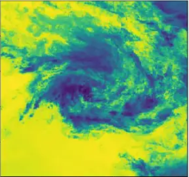 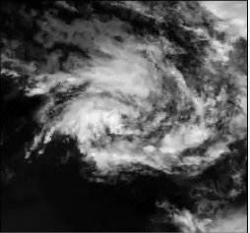

3.2 Pre-processing of the data

The most valuable information about a hurricane’s intensity is near the center. So, the satellite images are cropped to remove the outer part of the hurricane from the image. The satellite images are read using the netcdf library and converted to array by numpy library. The images are cropped to a 50-by-50-pixel square at the center. Sample of a cropped image is shown below

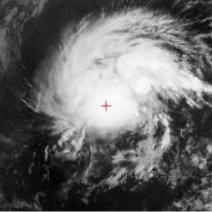

3.3 Convolution Layer

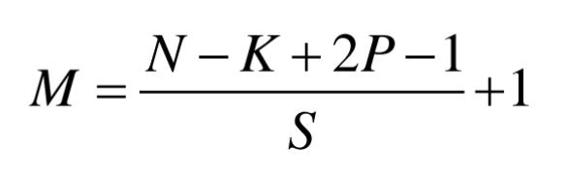Central to the convolutional neural network is the convolutional layer that gives the network its name. This layer performs an operation called a “convolution“. In the context of a convolutional neural network, a convolution is a linear operation that involves the multiplication of a set of weights with the input, much like a traditional neural network. Given that the technique was designed for two-dimensional input, the multiplication is performed between an array of input data and a two-dimensional array of weights, called a filter or a kernel. After applying the convolution operation, the output image is produced from equation

M is the Shape of output, N is input image shape, K filters, P is padding and S is Stride. Each convolution layer finalizes the feature vector based on activation functions like Relu, Sigmoid, Tanh and Leaky Relu.

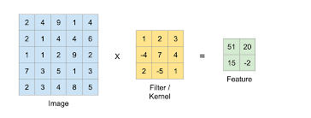

3.4 Activation function:

In a neural network, the activation function is responsible for transforming the summed weighted input from the node into the activation of the node or output for that input. For this model, we have used the ReLU activation function. ReLU stands for rectified linear activation unit and is considered one of the few milestones in the deep learning revolution In Rectified Linear Unit layer (Relu), the pixels value obtained from the convolution layer are converted into either 0 or 1. If any pixel containing any shade of important information then it is converted into 1 else it is converted into 0. ReLU is defined as:

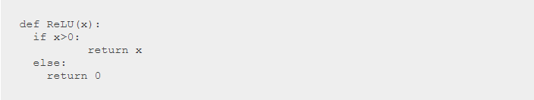

And is graphically represented as:

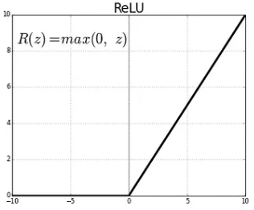

3.5 Pooling layer

The pooling layer compresses the dimension of the input image. A filter is selected and it is applied to the dimension matrix obtained from the convolution layer. The max pooling operation selects the maximum element from the region of the feature map covered by the filter. Max pool layer of pool size 2-by-2 are used after the conv2D layers.

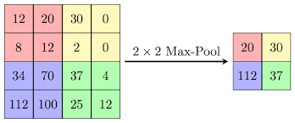

3.6 Model Architecture

The input layer is followed by Conv2D layer. The first Conv2D layer is trained with 32 filters, 50x50px input shape and with stride of 1x1. Batch normalization layer is also used after the first Conv2D layer to normalize the data which is then followed by the max pool layer. All in all 3 Conv2D layers are used followed by max pool layer the output of which is flattened and is fed to the Fully connected dense layer(FCN), also 3 “FCN “ are used the output of which is our estimated intensity. “ReLU” is used as the activation function in Conv2D and “FCN” layers. A basic CNN model architecture is represented below

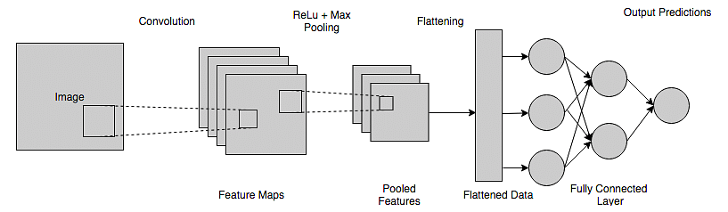

A detailed description of the architecture used for the model can be seen in the image below

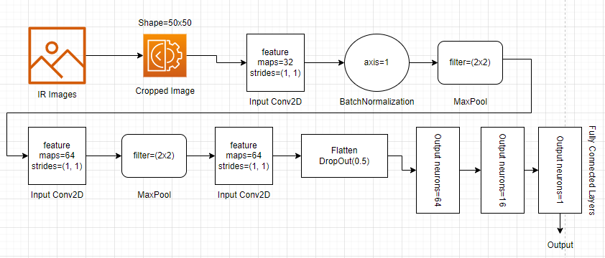

3.7 Model Training:

For the proposed model, we have used a batch size of 64 and trained the CNN model over 100 epochs. The CNN model was trained using a batch size of 32 and an initial learning rate of 0.001. RMSprop is used as the optimizer to optimize the model. The model was implemented using Python 3.9 and Keras with a Tensorflow backend. Optimizer plays a vital role in training. While training the network, the optimizer adjusts each neuron’s weights to reduce each epoch’s loss. This model is tested on different optimizers like Rmsprop, SGD (Stochastic gradient descent), Adam, Adagard and Adadelta

RMSprop increases the learning rate and our algorithm could take larger steps in the horizontal direction converging faster. The following equations show how the gradients are calculated for the RMSprop and gradient descent with momentum. The value of momentum is denoted by beta and is usually set to 0.9.

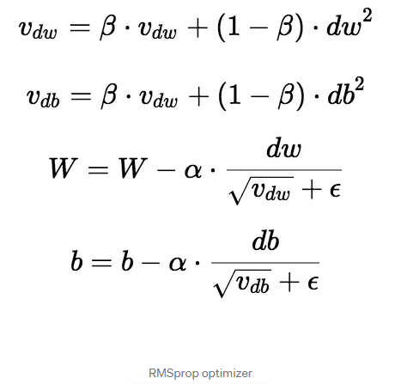

For evaluating loss, Mean Squared Error (MSE) is used as a metric. To calculate the MSE, we take the difference between the model’s predictions and the ground truth, square it, and average it out across the whole dataset. The MSE will never be negative, since we are always squaring the errors. The MSE is formally defined by the following equation:

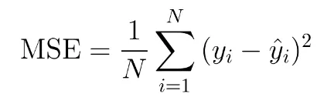

4. Result and Analysis

The proposed work has been implemented using Python on core i5 and 8 GB RAM system. The performance of the CNN-based model for tropical cyclone intensity estimation using infrared images was evaluated using a dataset of around 4000 tropical cyclone images. To increase the number of training and testing database data augmentation technique was also used. If the intensity was between 50-70 knots, 2 new images were generated. 6 new images are created for intensity between 75-100 knots and 12 images are created for above 100 knots.

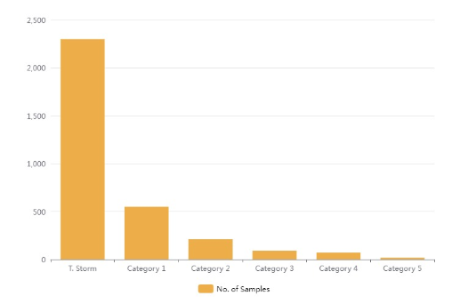

The performance of the model was evaluated using several metrics, including mean absolute error (MAE) and mean squared error (MSE). For model evaluation purposes, the K-fold validation technique with 5 folds was used.

The performance of the model was evaluated using the testing set. The MAE and MSE values for the model were 7.9 and 13.2 respectively. These results indicate that the model performed well in predicting tropical cyclone intensity from infrared images.

The performance of the model was also compared to other existing methods for tropical cyclone intensity estimation using infrared images. The proposed CNN-based model outperformed other existing methods in terms of MAE and MSE values.

Further analysis was conducted to investigate the importance of different features in predicting tropical cyclone intensity from infrared images. The results indicate that certain features, such as cloud temperature, cloud area, and cloud shape, are more important than others in predicting tropical cyclone intensity.

Below is a representation of the absolute error obtained by different categories of cyclone

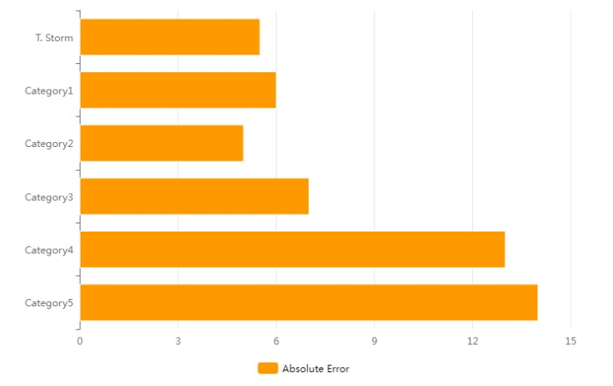

5. Deployment to Production System

The portal consists of an interactive UI where users can visually explore the estimated wind speed along with contextual information. The contextual information includes a map that shows storm location, the satellite image used for estimation, temporal information such as past observations and estimates. The design consideration of the portal focuses around a set of features, which are as follows.

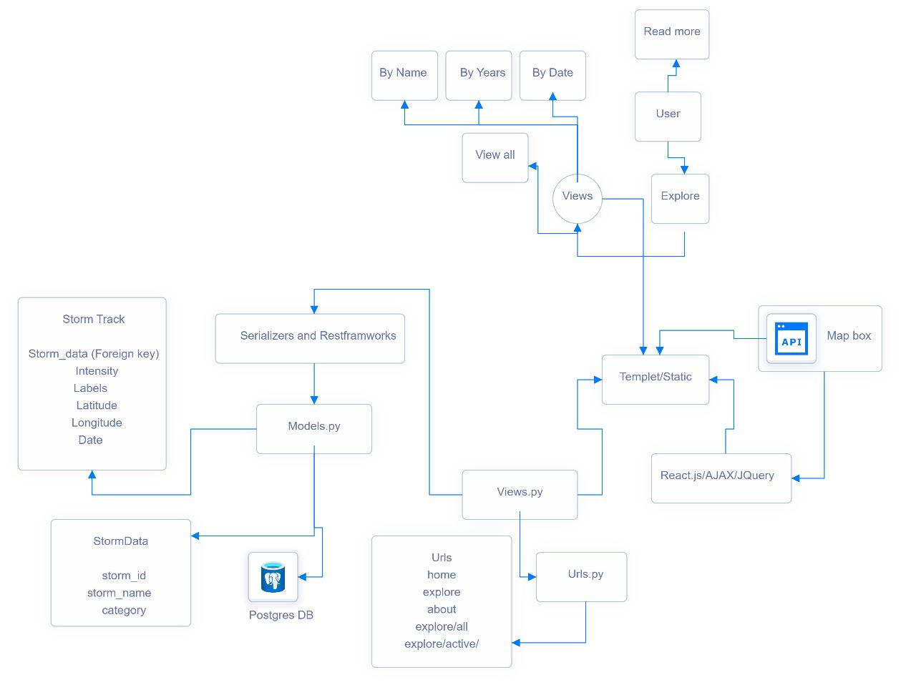

* The integral part of the portal is the UI. The primary goal of the UI is to provide an intuitive interpretation of the model outputs to the general science community. By default, an overview of current storms is presented in the portal. Detailed information about a particular storm, including current historical estimates and observed wind speeds, is presented. For this purpose, we used template engine and map box.
* Displaying estimated wind speed and complementary information over a map using map box API. Mapbox is a cloud-based mapping and location data platform that provides developers with tools and APIs to create custom maps, geocoding, and other location-based services. Mapbox is designed to be highly customizable and scalable, and it offers a range of features that can be used to build a wide variety of applications.
* Allowing comparison of the estimated wind speed against operational forecasts.
* Allowing download of archived estimation and satellite images for historical storms for deep dive of specific storms.
* User has two options read details and Explore, Explore has UI which shows world map and UI has features like year, search by name. After tapping on Cyclone, a description card will open.
* The MVT (Model View Template) is a software design pattern. It is a collection of three important components Model View and Template. The Model helps to handle database. It is a data access layer which handles the data. The Template is a presentation layer which handles User Interface part completely.

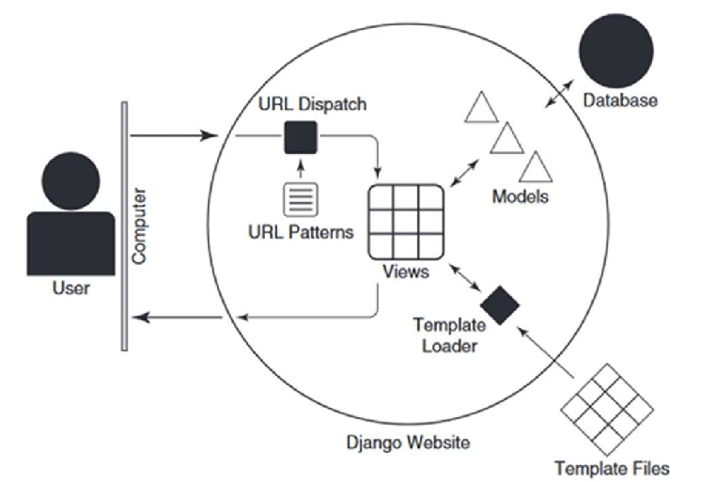

* There are two database models StormData and StormTrack in the project. StormData contains attributes StormID, cyclone name, category and StormTrack contains attributes such as the cyclone position, label, longitude, latitude, date, etc.

Tech Stack Used

* Machine Learning : Tensorflow/Keras, Matplotlib, Numpy, Pandas
* Front-end: Reactjs, Mapbox API
* Back-end: Django
* Database: PostgreSql
* Editors: Pycharm, VScode

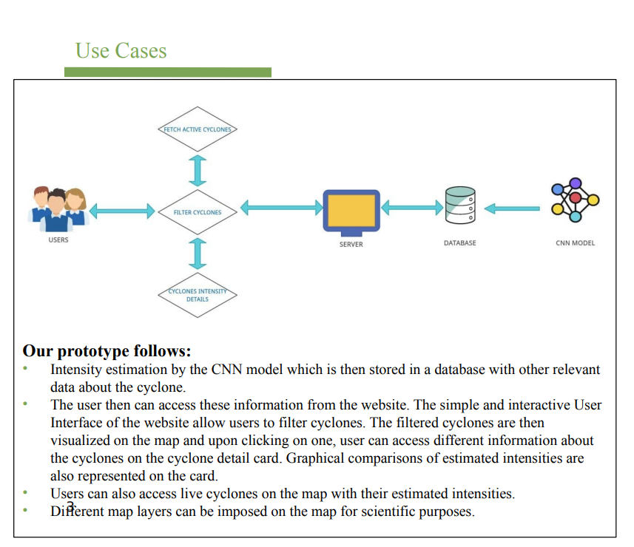

Our prototype follows:

• Intensity estimation by the CNN model which is then stored in a database with other relevant data about the cyclone.

• The user then can access these information from the website. The simple and interactive User Interface of the website allow users to filter cyclones. The filtered cyclones are then visualized on the map and upon clicking on one, user can access different information about the cyclones on the cyclone detail card. Graphical comparisons of estimated intensities are also represented on the card.

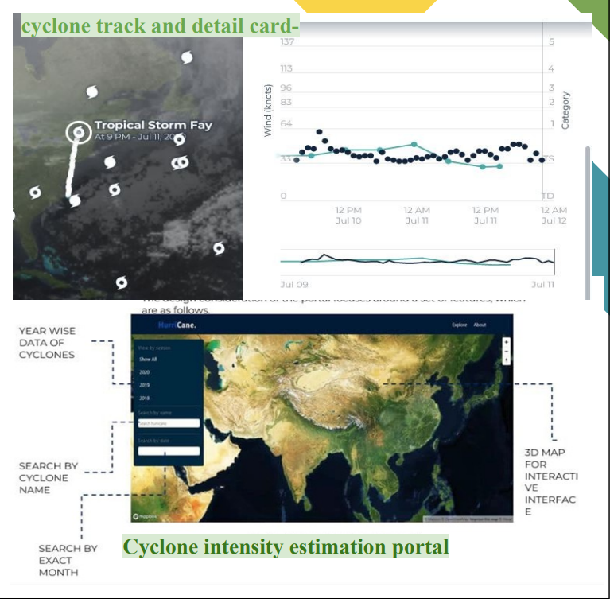

• Users can also access live cyclones on the map with their estimated intensities.

• Different map layers can be imposed on the map for scientific purposes.

6. Conclusion

In conclusion, the use of machine learning models to estimate cyclone intensity based on infrared images from satellites has shown promising results. The ability of these models to accurately predict cyclone intensity can assist in providing timely and accurate information to governments and communities in affected areas, ultimately contributing to better disaster preparedness and response. While further research is necessary to refine and improve these models, they hold great potential for improving our understanding and response to severe weather events.

Tropical cyclones have been a concern of meteorologists for more than 100 years. Numerous scholars have conducted in-depth studies on key issues, such as the structure, dynamics, and forecasting techniques. Machine learning is derived from statistical methods that can automatically discover relevant rules from large-scale data for detection, analysis, prediction, etc. The application of machine learning for the key problems of TCs provides a new way of thinking to address many bottlenecks in this field. Techniques based on a pure data-driven approach and using machine learning to improve numerical models have both been shown by a large number of studies to provide huge contributions to improving TC predictions. Although existing research has made some progress in genesis forecasts, path prediction, intensity prediction, TC weather prediction, and improving numerical forecast models by integrating machine learning, there are still many aspects that remain to be studied, which we regard as both an opportunity and a challenge.

The opportunity is that the potential of machine learning has not yet been exploited, and large-scale data are still underutilized. The challenge is that TCs are different from normal weather phenomena and oceanic physical processes in that they are complex, subject to many factors, and it is difficult to obtain comprehensive in situ observations inside TCs. We can conclude that machine learning in TC forecasts is both promising and challenging, which means that it requires researchers to have a good understanding of TC dynamics as well as a knowledge of machine learning in order to discover the key problems faced and to solve them by building suitable machine learning models. By analyzing and summarizing the studies of machine learning in TC forecasts over the years, we hope this review can provide readers with insight into this research and lay a foundation for future works regarding machine learning in TC forecast modeling.

The website provides a valuable resource for researchers, disaster response teams, and the general public, by providing easy access to accurate and reliable information about past cyclones. The use of a CNN model for intensity estimation and a database for storage of relevant information, combined with a user-friendly interface, represents a significant step forward in our ability to manage and mitigate the impacts of severe weather events.

7. References

1.<https://en.wikipedia.org/wiki/Tropical_cyclone>

2.<https://www.metoffice.gov.uk/research/weather/tropicalcyclones/facts#What%20is%20a%20TC>

3.Olander, T.; Velden, C. The advanced Dvorak technique: Continued development of an objective scheme to estimate tropical cyclone intensity using geostationary infrared satellite imagery. Weather Forecast. 2007, 22, 287–298.

4.Olander, T.; Velden, C. The advanced Dvorak technique (ADT) for estimating tropical cyclone intensity: Update and new capabilities. Weather Forecast. 2019, 34, 905–922.

5.<https://journals.ametsoc.org/view/journals/mwre/147/6/mwr-d-18-0391.1.xml>

6.https://ijariie.com/AdminUploadPdf/Cyclone_Intensity_Estimation_Using_INSAT_3D_IR_Imagery_and_deep_learning_ijariie19285.pdf

7.<https://ieeexplore.ieee.org/stamp/stamp.jsp?tp=&arnumber=9320562>

8.<https://ieeexplore.ieee.org/document/9044856>

9.<https://ntrs.nasa.gov/api/citations/20205004901/downloads/FINAL%20VERSION.PDF>

10. <https://www.frontiersin.org/articles/10.3389/fmars.2022.1077901/full>

11. <https://www.frontiersin.org/articles/10.3389/fmars.2022.1077901/full>

12. Pineros, M.; Ritchie, E.; Tyo, J. Objective measures of tropical cyclone structure and intensity change from remotely sensedcinfrared image data. IEEE Trans. Geosci. Remote Sens. 2008, 46, 3574–3580.

13. Ritchie, E.; Valliere-Kelley, G.; Piñeros, M.; Tyo, J. Tropical cyclone intensity estimation in the North Atlantic basin using an improved deviation angle variance technique. Weather Forecast. 2012, 27, 1264–1277.

14. Ritchie, E.; Wood, K.; Rodríguez-Herrera, O.; Pineros, M.; Tyo, J. Satellite-derived tropical cyclone intensity in the North Pacific Ocean using the deviation-angle variance technique. Weather Forecast. 2014, 29, 505–516.

15. Li, L.; Zhou, Y.; Wang, H.; Zhou, H.; He, X.; Wu, T. An Analytical Framework for the Investigation of Tropical Cyclone Wind Characteristics over Different Measurement Conditions. Appl. Sci. 2019, 9, 5385.

16. Hay, J.; Mimura, N. The changing nature of extreme weather and climate events: Risks to sustainable development. Geomat. Nat. Hazards Risk 2010, 1, 3–18.

17. Devaraj, J.; Elavarasan, R.M.; Pugazhend, R.; Shafiullah, G.M.; Ganesan, S.; Jeysree, A.K.; Khan, I.A.; Hossain, E. Forecasting of COVID-19 cases using deep learning models: Is it reliable and practically significant? Results Phys. 2021, 21, 103817.

18. Raz, T.; Liwag, C.R.E.U.; Valentine, A.; Andres, L.; Castro, L.T.; Cuña, A.C.; Vinarao, C.; Raza, T.K.S.; Mchael, K.; Marsian, E.; et al. Extreme weather disasters challenges for sustainable development: Innovating a science and policy framework for disaster-resilient and sustainable, Quezon City, Philippines. Prog. Disaster Sci. 2020, 5, 100066.

19. Bao, X.; Jiang, D.; Yang, X.; Wang, H. An improved deep belief network for traffic prediction considering weather factors. Alex. Eng. J. 2021, 60, 413–420.

20. Devaraj, J.; Elavarasan, R.M.; Shafiullah, G.M.; Jamal, T.; Khan, I. A holistic review on energy forecasting using big data and deep learning models. Int. J. Energy Res. 2021.

21. Anbarasana, M.; Muthu, B.A.; Sivaparthipan, C.B.; Sundarasekar, R.; Dine, S. Detection of flood disaster system based on IoT, big data and convolutional deep neural network. Comput. Commun. 2020, 150, 150–157.

22. Rysman, J.L.L.; Claud, C.; Dafis, S. Global monitoring of deep convection using passive microwave observations. Atmos. Res. 2021, 247, 105244.

23. Tien, D.; Nhat-DucHoang, D.; Martínez-Álvarez, F.; Thi Ngo, P.; Viet Hoa, P.; Dat Pham, T.; Samui, P.; Costacheij, R. A novel deep learning neural network approach for predicting flash flood susceptibility: A case study at a high frequency tropical storm area. Sci. Total Environ. 2020, 701, 134413.

24. Kordmahalleh, M.M.; Sefidmazgi, M.G.; Homaifar, A.A. A Sparse Recurrent Neural Network for Trajectory Prediction ofAtlantic Hurricanes. In Proceedings of the Genetic and Evolutionary Computation Conference (GECCO’ 16), Denver, CO, USA,20–24 July 2016; pp. 957–964.

25. Mangalathu, S.; Burton, H.V. Deep learning-based classification of earthquake-impacted buildings using textual damage descriptions. Int. J. Disaster Risk Reduct. 2019, 36, 101111.

26. Alemany, S.; Beltran, J.; Perez, A.; Ganzfried, S. Predicting Hurricane Trajectories Using a Recurrent Neural Network. In Proceedings of the Thirty-Third AAAI Conference on Artificial Intelligence (AAAI-19), Honolulu, HI, USA, 27 January–1 February 2019.

27. Chen, R.; Wang, X.; Zhang, W.; Zhu, X.; Li, A.; Yang, C. A hybrid CNN-LSTM model for typhoon formation forecasting. Geoinformatica 2019, 23, 375–396.

28. Mohammadi, M.E.; Watson, D.P.; Wood, R.L. Deep Learning-Based Damage Detection from Aerial SfM Point Clouds. Drones 2019, 3, 68.

29. Zhou, K.H.; Zheng, Y.G.; Li, B. Forecasting different types of convective weather: A deep learning approach. J. Meteorol. Res. 2019, 33, 797–809.

30. Snaiki, R.; Wu, T. Knowledge-enhanced deep learning for simulation of tropical cyclone boundary-layer winds. J. Wind Eng. Ind. Aerodyn. 2019, 194, 103983.

31. Chen, B.F.; Chen, B.; Elsberry, R.L. Estimating Tropical Cyclone Intensity by Satellite Imagery Utilizing Convolutional Neural Networks. Weather Forecast. 2019, 34, 447–465.

32. Castro, R.; Souto, Y.M.; Ogasawara, E.; Porto, F.; Bezerra, E. STConvS2S: Spatiotemporal Convolutional Sequence to Sequence Network for weather forecasting. Neurocomputing 2020, 426, 285–298.

33. Kim, S.; Kim, H.; Lee, J.; Yoon, S.W.; Kahou, S.E.; Kashinath, K.; Prabhat, M. Deep-Hurricane-Tracker: Tracking and Forecasting Extreme Climate Events. In Proceedings of the IEEE Winter Conference on Applications of Computer Vision (WACV), Waikoloa Village, HI, USA, 7–11 January 2019. Appl. Sci. 2021, 11, 4129 39 of 39.

34. Li, Y.; Hu, W.; Dong, H.; Zhang, X. Building Damage Detection from Post-Event Aerial Imagery Using Single Shot Multibox Detector. Appl. Sci. 2019, 9, 1128.

35. Haghroosta, T. Comparative study on typhoon’s wind speed prediction by a neural networks model and a hydrodynamical model. MethodsX 2019, 6, 633–640.

36. Chen, Y.; Zhang, S.; Zhang, W.; Peng, J.; Cai, Y. Multifactor spatio-temporal correlation model based on a combination of convolutional neural network and long short-term memory neural network for wind speed forecasting. Energy Convers. Manag. 2019, 185, 783–799.

37. Neshat, M.; Nezhad, M.M.; Abbasnejad, E.; Mirjalili, S.; Tjernberg, B.L.; Garcia, A.D.; Alexander, B.; Wagner, M. A deep learningbased evolutionary model for short-term wind speed forecasting: A case study of the Lillgrund offshore wind farm. Energy Convers. Manag. 2021, 236, 114002.

38. Meka, R.; Alaeddini, A.; Bhaganagar, K. A robust deep learning framework for short-term wind power forecast of a full-scale wind farm using atmospheric variables. Energy 2021, 221, 119759.

39. Krizhevsky, A.; Sutskever, I.; Hinton, G. ImageNet classification with deep convolutional neural networks. In Proceedings of the NIPS’12 Information Processing Systems, Lake Tahoe, NV, USA, 3–6 December 2012; Volume 1, pp. 1097–1105.

40. Bengio, Y.; Courville, A. Deep learning of representations. In Handbook on Neural Information Processing; Springer: Berlin, Germany, 2013; Volume 49, pp. 1–28.